Which UML diagram is shown below? Mahesh kudskjsu

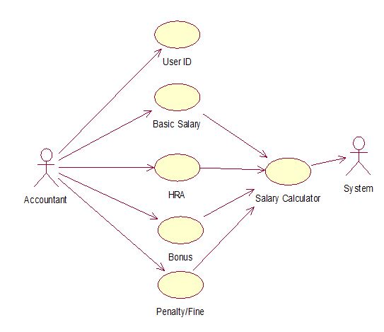  
**a) Use Case**  
b) Collaboration Diagram  
c) Class Diagram  
d) Object Diagram

3. Which UML diagram is shown below?  
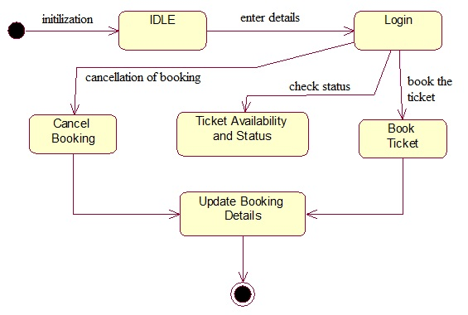  
a) Use Case  
b) State Chart  
**c) Activity**  
d) Object Diagram

4. Which UML diagram is shown below?  
[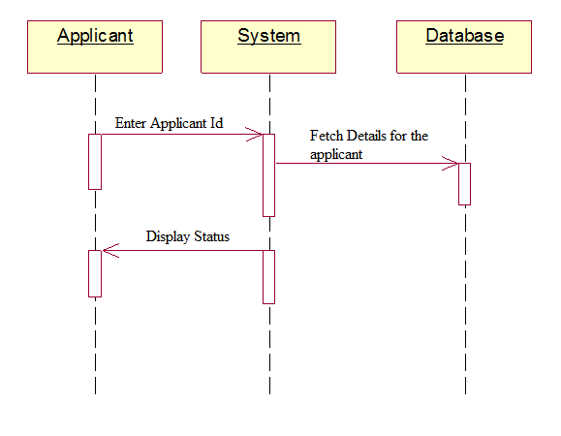](https://www.sanfoundry.com/wp-content/uploads/2013/07/software-engineering-multiple-choice-questions-answers-q4.png)  
a) Use Case  
b) Collaboration Diagram  
**c) Sequence Diagram**  
d) Object Diagram

5. Which UML diagram’s symbols are shown below?  
[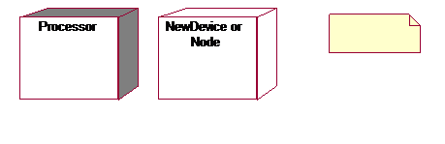](https://www.sanfoundry.com/wp-content/uploads/2013/07/software-engineering-multiple-choice-questions-answers-q5.png)  
**a) Deployment diagram**  
b) Collaboration Diagram  
c) Component Diagram  
d) Object Diagram

Subscribe Software Engineering Newsletter

6. Which UML diagram is shown below?  
[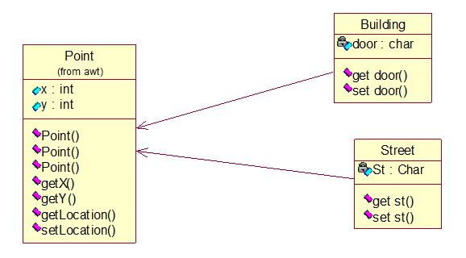](https://www.sanfoundry.com/wp-content/uploads/2013/07/software-engineering-multiple-choice-questions-answers-q6.png)  
a) Deployment diagram  
b) Collaboration Diagram  
c) Object Diagram  
**d) Class Diagram**

7. Which UML diagram is shown below?  
[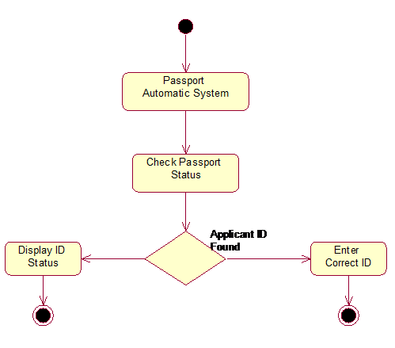](https://www.sanfoundry.com/wp-content/uploads/2013/07/software-engineering-multiple-choice-questions-answers-q7.png)  
**a) Activity**  
b) State chart  
c) Sequence  
d) Collaboration

8. Which UML diagram is shown below?  
[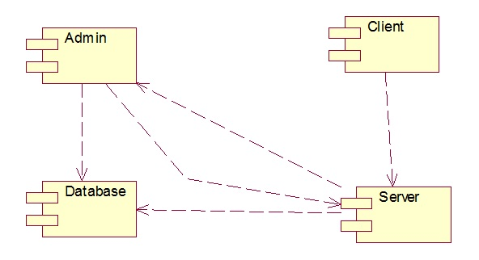](https://www.sanfoundry.com/wp-content/uploads/2013/07/software-engineering-multiple-choice-questions-answers-q8.png)  
**a) Component**  
b) Deployment  
c) Use Case  
d) DFD